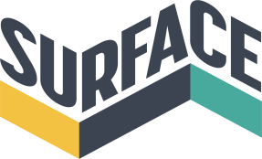 | 16 Southwell Road / Nottingham / NG1 1DL info@surfacegallery.org  www.surfacegallery.org  0115 947 0793

Exhibition Proposal Form

Name:

Address:

Phone number:

Email:

I / we are interested in (please mark box with Y (YES):

Solo Show
Group show

Gallery Space

 | One week exhibition | £400
 | Twoweek exhibition | £600
 | Threeweek exhibition | £750

Project Space

 | One week exhibition | £300
 | Two week exhibition | £500
 | Three week exhibition | £650

Gallery and Project Space

 | One week exhibition | £600
 | Two week exhibition | £900
 | Three week exhibition | £1,100

Le Loovre

 | Exhibition (flat rate) | £30

For longer exhibitions, please enquire.

Period interested in Exhibiting

January – March
April – June
July – September
October – December
Flexible

Any specific dates:

Would you be interested in doing an artist’s talk during your exhibition?

Yes
No

Any additional information / requirements?

Supporting Material

- A completed Application Form
- An exhibition proposal outlining ideas and details of the proposed exhibition. This must be no more than 750 words.Please include:
  - Details of the work which will be exhibited (medium, materials, scale)
  - A small blurb about the nature of the show e.g. relevant concepts or themes
- 300 word max artist statement to be provided by each exhibiting artist
- Artist CV to be provided by each exhibiting artist. Please include links to relevant websites and blogs
- Strong images or diagrams of artwork that will be exhibited or work of a similar nature
- This is to be formatted and sent as an inclusive PDF or Word Document containing the information requirements stated above

Please send your application form and supporting material to info@surfacegallery.org

